Roberto Cruz

Minesweeper

Milestone 1

CS111

Instructor Lynch

**Where I got most of my information:** <http://twolivesleft.com/Codea/Talk/discussion/1335/tutorial-6-building-a-minesweeper-game-part-1/p1>

**Pictures:**

Making A Move: Enclosed as file “MineTerminal”

Board before game starts: Enclosed as file “EmptyBoard”

Minesweeper Win: Enclosed as “GameWon”

Minesweeper Lost: Enclosed as “GameLost”

**Inputs:**

1. Ask user to input x value of board
2. Ask user to unput y value of board
3. Ask user to input a location (1, a) (1, b) (2, j) etc…
4. Allow user to flag a certain location. flag (1, a) flag (1, b) flag (2, j) etc…

Outputs:

1. Should allow user to see minesweeper board from the beginning(fresh board)
2. Should allow user to see minesweeper board when user checks a square(effect of selecting a square and all the squares that are revealed as a result of it).
3. Should allow user to see minesweeper board when user flags a square(flag notification)
4. Should allow user to see minesweeper board when user loses(lost notification)
5. Should allow user to see minesweeper board when user wins(win notification)

How does Minesweeper work?

First, you must start off by opening Minesweeper. You can locate minesweeper on most

windows computer by going to Start-àAll ProgramsàGames-àMinesweeper.

Second, you have the option of selecting a difficulty level. At the upper-left hand

corner, you can select between Beginner, Intermediate, Expert, or Custom. Solely a

recommendation, but if you’re new, the beginner level is a good place to start.

The next part is very simple; all you have to do is click a square. Players play by clicking

on random squares until a group of squares opens up. For example, if only one square

opens after you click, then you just have to find another square to click.

Part four is understanding what each individual number means. If you see the number

one, then that means that 1 square is touching a single mine.

After understanding this concept, it is important to tackle the squares that surrounds the

mines that may contain bombs(the ones surrounded by the ones).

In order to remember if a mine exists on a certain spot you can right click it to flag the

square, representing your confusion.

After you have flagged all the possible squares that may be mines, you must go back and

re-evaluate your decision. If the game does not end, then you know that you are missing

squares that are not bombs!

Once all of these steps have been accomplished, you must practice playing and work your

way up to the highest difficulty until you feel you have mastered minesweeper.

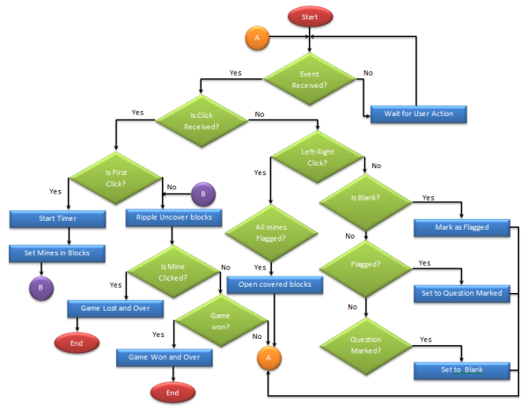

**Flowchart:**